**19. Introduction to Amazon DynamoDB**

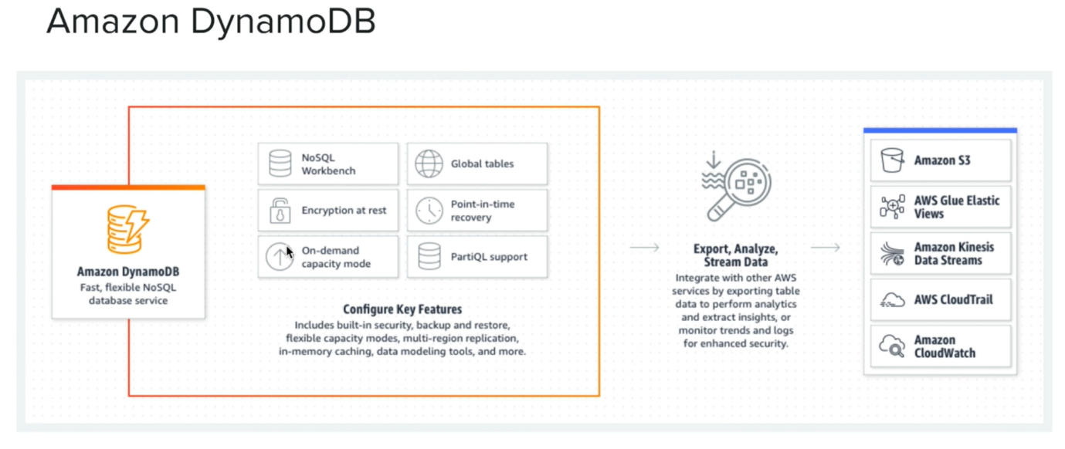

* let us talk about Amazon Dynamo DB. Amazon Dynamo DB is a No-sql service offering from AWS. the main advantage of using Dynamo DB is that it guarantees single millisecond latency for any scan and on top of that you can add caching With Dex or Dynamo DB accelerator in order to reduce the latency further at microsecond level.
* there is one thing you should remember is that in order to guarantee these latencies, you must design your dynamo DB table according to your data access patterns in your application. How to decide the primary keys which consist of hash key or hash key plus range key. Maybe look at that in just a little bit and you also must decide on your global secondary indexes and local secondary indexes.
* So essentially, you must put a little bit thought on data modelling with Dynamo DB. Now you can find more information about Dynamo DB data modelling in the reference section. Now here are the features of Dynamo DB. Dynamo TV supports encryption at rest and there is this point in time recovery and Dynamo DB has something called Global Tables, which can be used for disaster recovery and for multi region architectures. When you create Dynamo DB table, you can decide on the capacity mode. Either you can select the on-demand capacity mode. That means that you will be paid for your request or you can have some provision capacity.
* Now let us have a look at the Dynamo DB service in aws console.

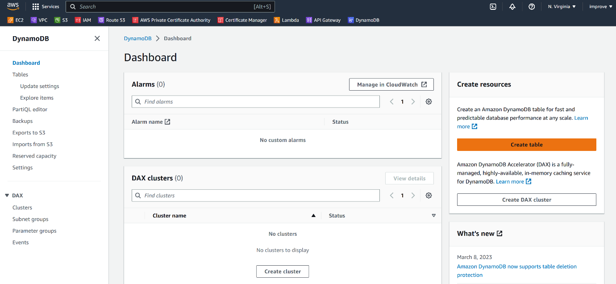

--- click on create table.

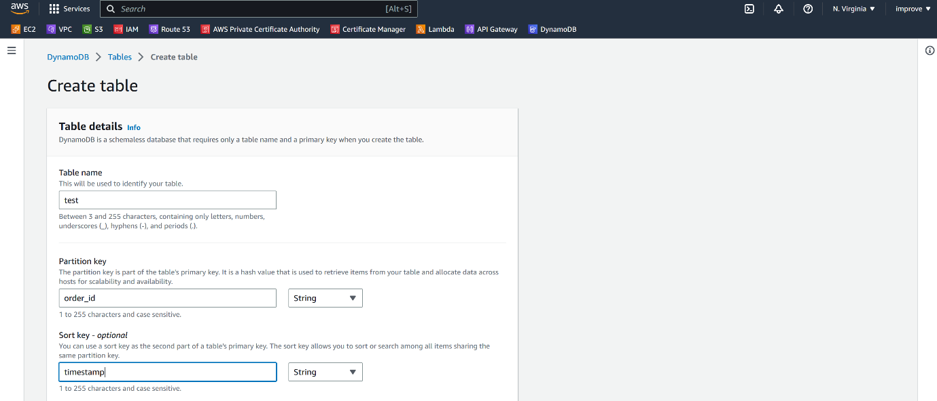

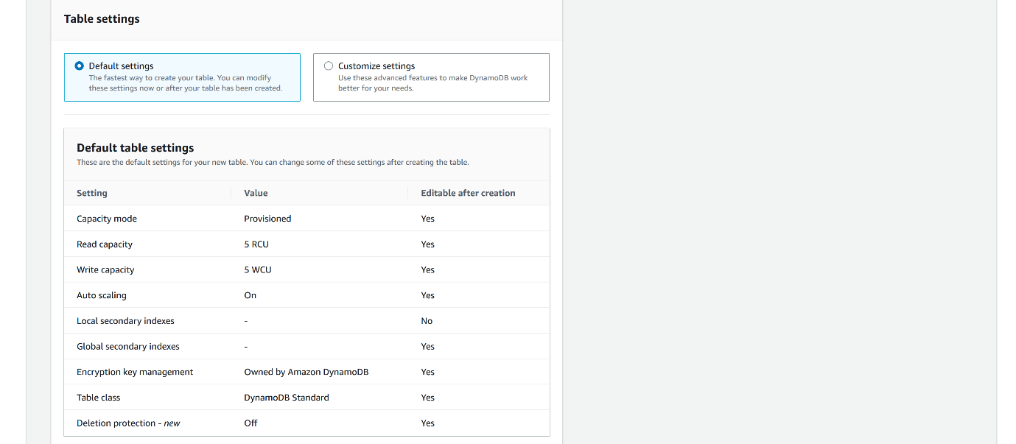

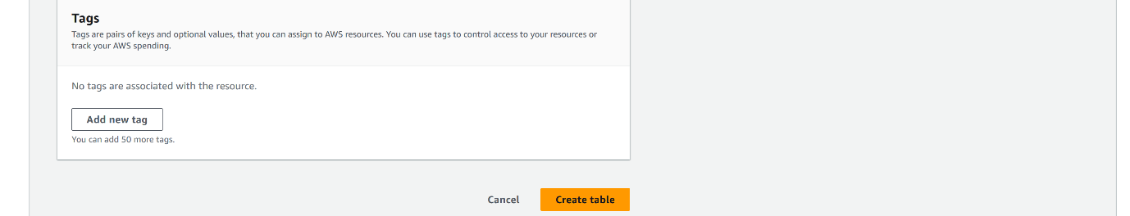

* Now here I can go ahead and create a table. I can give it a name and this is the place we must define our partition key. So, in Dynamo DB, you can either define a hash key as the partition key, or we can combine the hash key with sort key and have sort of a composite partition key.
* Now this one important thing that you should remember in Dynamo DB, you can add other attributes apart from the partition key, which is hash and the sort key, but you cannot directly query on top of them. Now there is a way that we can use the Dynamo DB scan operation and use non key attributes in the field expression to query with them but the queries are not efficient. if you want to do efficient query for Non key attribute, you must create global secondary indexes for those non key attributes.

--- click on customize setting

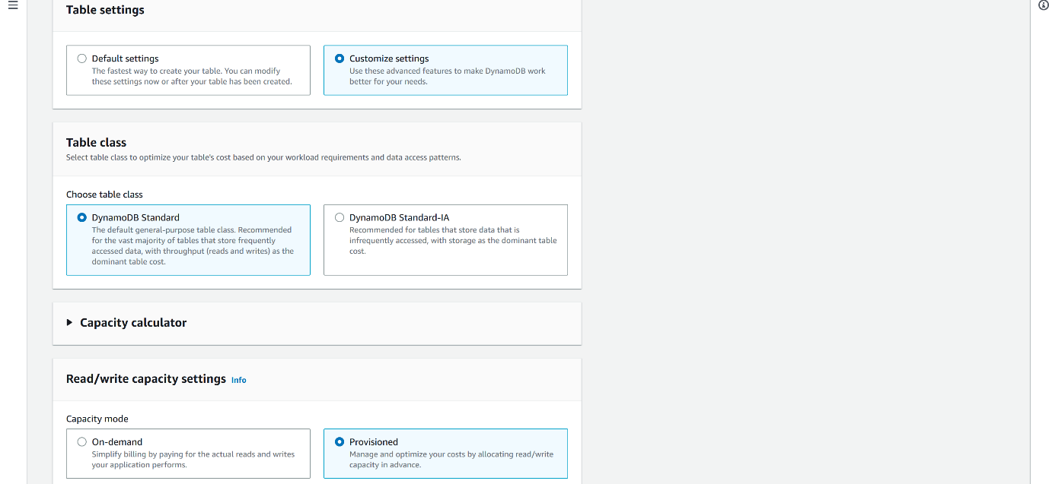

--- Click on select on-demand,

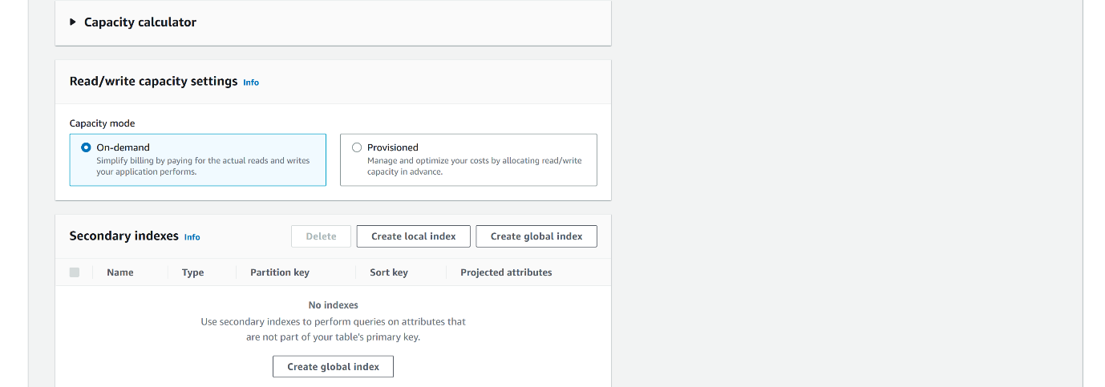

* by default, the provision capacity is selected but if your users access your application in an ad hoc manner, then it would be good to go ahead with on demand capacity and you can define your indexes, particularly you can create local indexes at the time of creating the Dynamo DB table and you can create global secondary indexes as well.

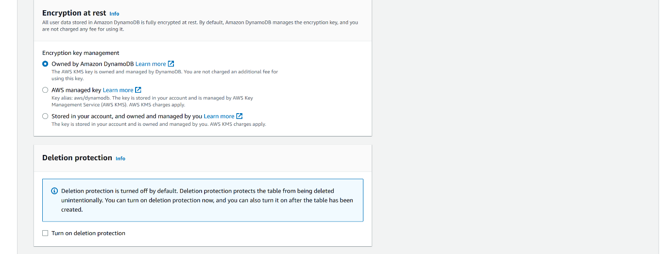



* Now this is the section that we can set up encryption at addressed and then we can go ahead and create the table. So, the table is created.

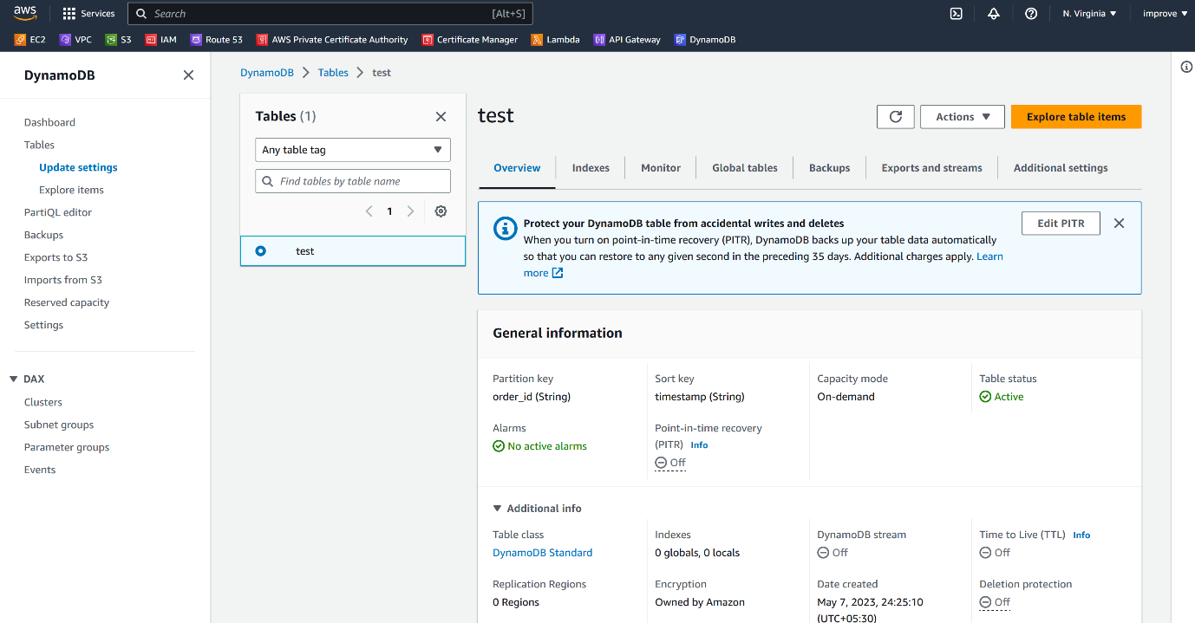

we can select additional information. Now, here I can see the Dynamo DB stream, point in time, recovery detail and TTL (time to leave) is disabled. Now when we enable TTL, we can define a time to leave value for every record.

**Enable TTL value**

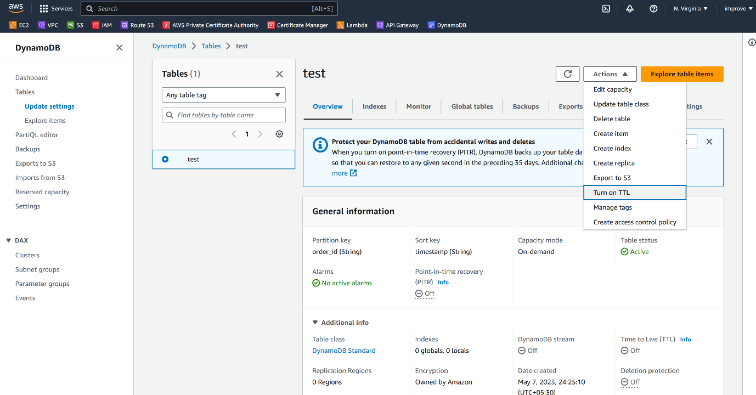

**DynamoDB stream details**

--- under exports and streams

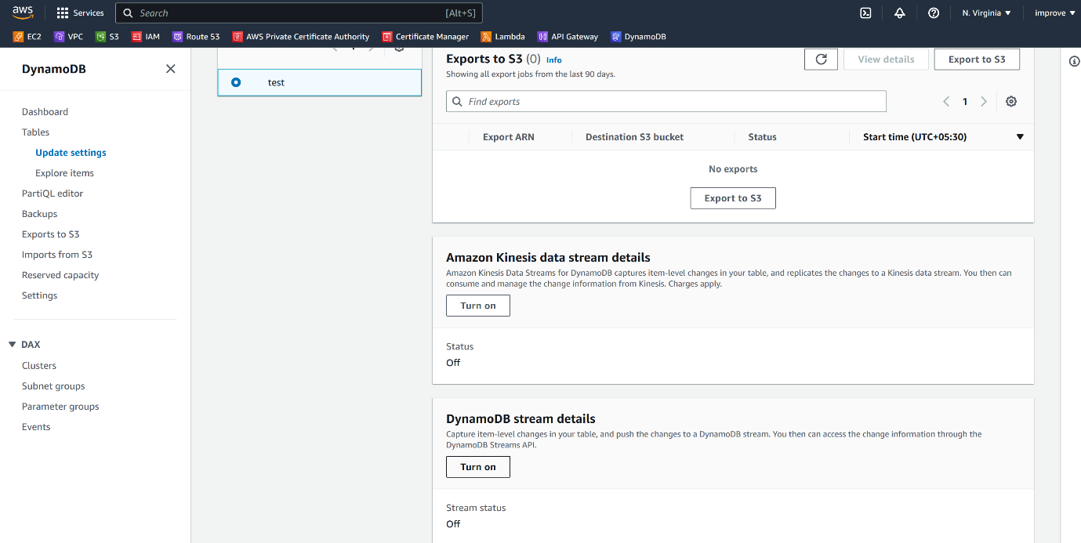

--- click on turn on.

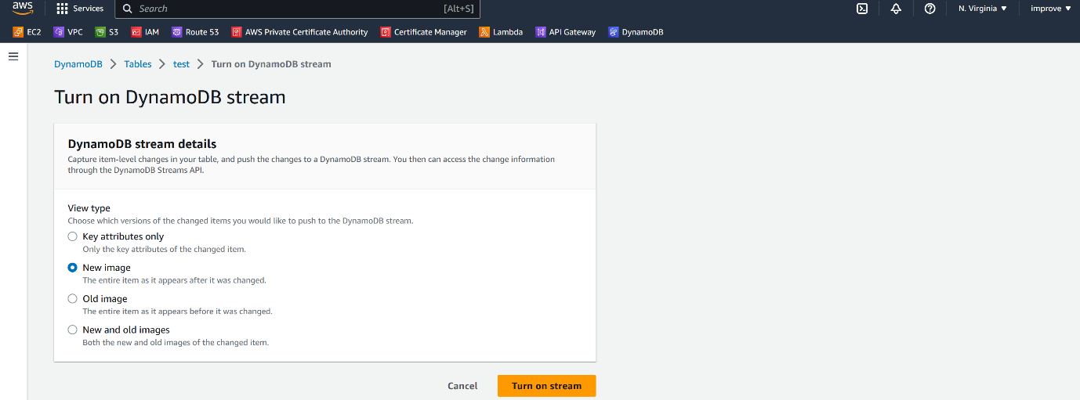

Now here we can decide once we put some data into a Dynamo DB, what should Dynamo DB stream out? Is it only the key attributes or is it the entire new item, or is it the item that was replaced by the new item. Do we want to omit both the new and old items like select the new image and enable the stream?

So, when we enable dynamo DB streams, we can asynchronously listen for these Dynamo DB streams by AWS lambda and run business logic or call other AWS services. So, Dynamo DB streams really enable the developers to create event driven architectures very easily.

**Enable Backups**

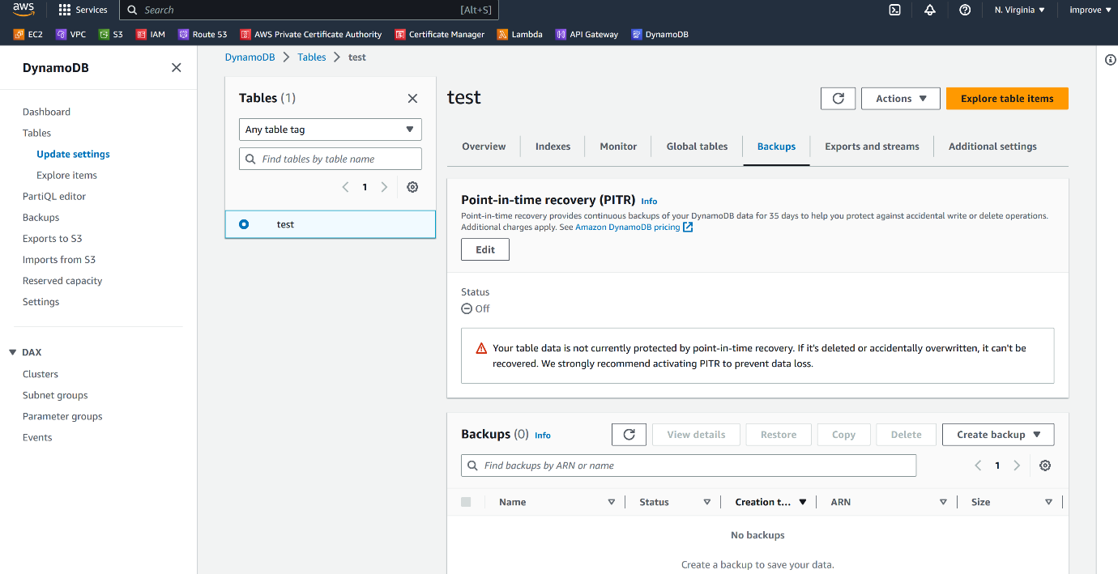

If you go to the backup section, I can go ahead and enable point in time recovery.

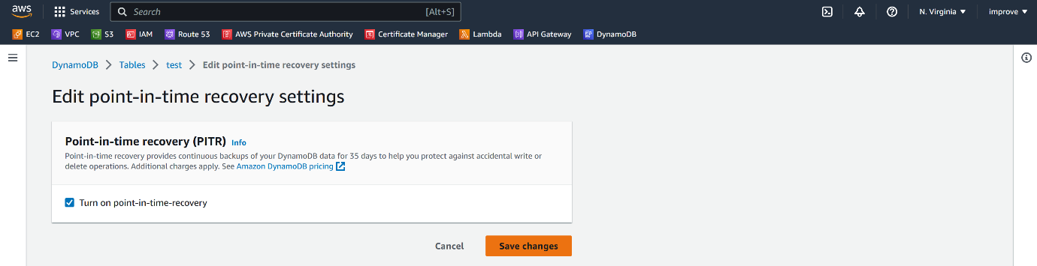

--- click on save changes.

**Global tables**

I can create a replica of this table in another region.

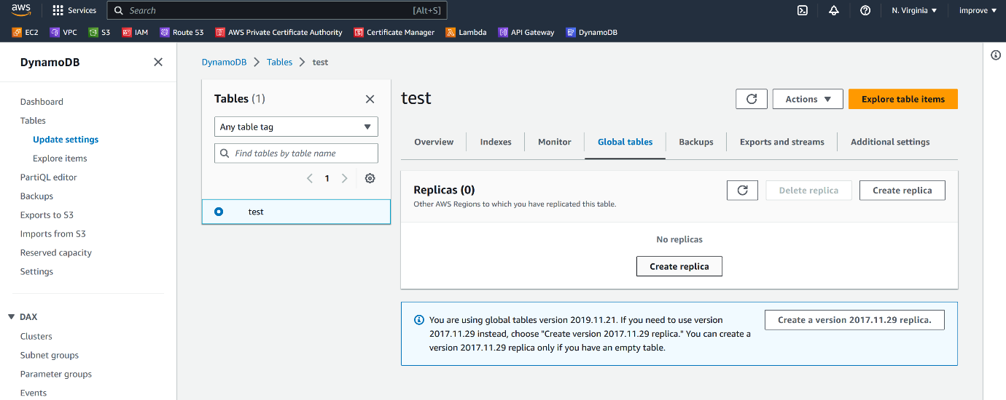

* go to the global table section.
* So, when we enable a global table with one or more regions, whenever a data is added to this table, it will be replicated to other region tables.

**Indexes**

here is the indexes section where we can create global secondary indexes. Now notice that we cannot create LSI or local secondary indexes after the table is created. We can only create theses global secondary indexes.

**Monitoring**

Now in the monitoring tab, we can set up alarms for default cloud watch metrics for Dynamo DB. Now here are the default metrics. we can create an alarm on these metrics.

**DAX**

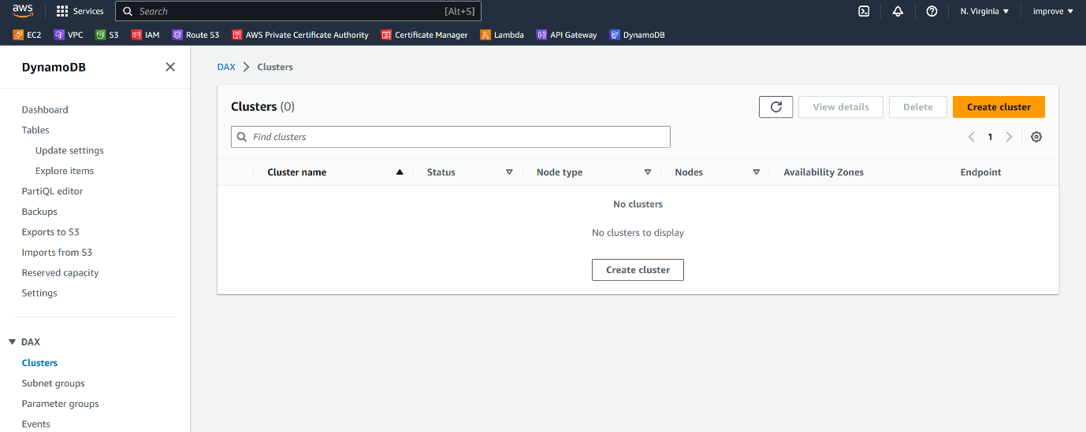

Now here we have dax on the left side section. So, decks are nothing but Dynamo would be accelerated or read through right through cache. So here you can create a desk cluster and associated with our Dynamo DB.